dancing girl press Releases The Wendy Bird Poems by Nettie Farris

ABOUT THE CHAPBOOK:
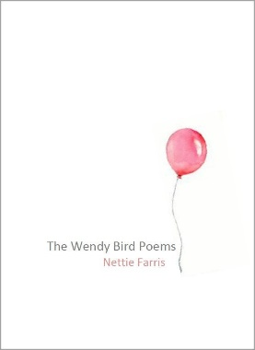
The Wendy Bird Poems consists of 28 slim lyrical poems. Invoking the childhood literature of J. M. Barrie and Robert Louis Stevenson in addition to the minimalist aesthetics of Marie Kondo as reflected in The Life-Changing Magic of Tidying Up: The Japanese Art of Decluttering and Organizing, these poems juxtapose child-like whimsy with the spiritual journey toward maturity.

PRAISE:

Indeed! I simply adore these slender poems. Farris knows how to spin and craft and shape the smallest of poems, how to turn the word as on lathe to shave away all that is unnecessary. It is not that she has grown accustomed to the diminished size, it is that she works with the tension between what is said and unsaid, with the tiniest of head nod and wink, and in the smallest of spaces she lays bare great psychological drama that opens up into insight. Do not think because the line is minimal and the poem short that you can skim across the surface of these words.
-Jeremy Paden,
Author of ruina montium
(Broadstone Books, 2016)
The Wendy Bird Poems is a truly unique book, and Nettie Farris is a truly unique poet. The collection encompasses a tender love story, so delicate, that it needs to be told not in sentences, not in words even, but in syllables. The content is distilled to such an extent that we need to be aware of the importance and the weight of every sound. Nettie Farris gives us a huge gift with this book – not only does she present a new kind of poetry, but also she teaches us to read in a new way, to see poems anew. Dear reader, enjoy this work, read it slowly and multiple times. These poems will teach you about sound, lineation, intention.
-Katerina Stoykova-Klemer,
Senior Editor/Founder Accents Publishing
ABOUT THE AUTHOR:
Nettie Farris is the author of Communion (Accents Publishing, 2013), Fat Crayons (Finishing Line Press, 2015), and the micro-chapbook Story (Origami Poems Project, 2016). A book reviewer, she writes the feature Spotlight on a Press for Blue Lyra Review. She read Peter Pan to each of her three sons.
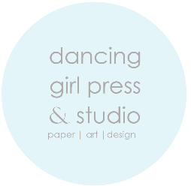
An indie press and design studio based in Chicago, dancing girl press & studio creates a variety of open and limited edition books, art, and paper goods. Since 2004, the annual dgp chapbook series has been devoted to publishing innovative writing by women authors in delectable handmade editions. Visit dancing girl press at https://dulcetshop.myshopify.com/products/the-wendy-bird-poems-nettie-farris.

